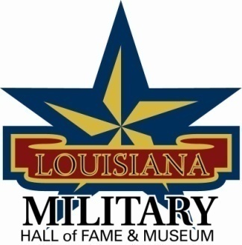

LA Military Hall of Fame & Museum
Chris Crusta Memorial Airport
911 Revis Sirmon Loop
Abbeville, LA 70510
337-898-9645

Governing Board Meeting Minutes – Saturday, September 28, 2013
10:00 am inside the Military Hall of Fame & Museum

Attendees: Guests:
General Robert LeBlanc Crystal Mouton
Johnny Raymond Carol Raymond
Dewey Coles Pete LeBlanc
Randy Vidrine
Joe Hill
Al Leger
David Couvillon

The meeting was called to order at 10:00 am and followed by Prayer led by Randy Vidrine and Pledge of Allegiance led by Dewey Coles.

Mr. Pete LeBlanc demonstrated the new computer system and how to use it for the new veteran data base. Mr. LeBlanc will also present the program to the City of Abbeville city council to see if they would like to help fund the purchasing of the program.

Johnny Raymond will work with Al Leger for wording so we can go to the legislation to have a bill passed for the museum to retrieve copies of veterans discharge papers.

A committee was formed for the “Hall of Distinction” The board members are Randy Vidrine, Joe Hill, and David Couvillon. This committee will help to distinguish between veterans and civilians who have supported veterans and have clearly distinguished themselves and have carried out within the communities.

Dewey Coles discussed the upcoming Induction Ceremony to be help inside the VFW on Jimmy C. Vorhoff drive and a reception following inside the museum. The ceremony will be at 2:00 pm on Saturday, November 16, 2013.

Upcoming Veteran Events:
- September 28 & 29, 2013 will be the Chenault Air show
- October 12, 2013 Cadets of the Old War Scholl will be inducted into the Hall of Honor at the LSU Game.
- November 9, 2013 Medal of Honor recipient Doug Fournet statue will be erected at Veterans Park in Lake Charles at an 11:00 ceremony. Bill Fournet will be the guest speaker.
- The USS Arlick is open to the public for viewing in Lake Charles on Thursday – Sundays from 10:00-4:00.

The meeting was adjourned at 11:46

ral Bob
Leblanc, President
Abbeville

John R. Raymond, Vice President
Breaux Bridge

N.R. Bubba Broussard, Secretary
Abbeville

Joey LeRouge, Treasurer
Lafayette

Secretary Lane Carson
Baton Rouge

Louis Michot
Lafayette

Adrian Bruneau
Jefferson

Joe D. Hill
Lake Charles

Don Sands
Lafayette

Dewey Coles,
Breaux Bridge

Felix Weill
Baton Rouge

Stan Wall
West Monroe

Peyton Cole
Bossier City

